OBJECTIVE:

To improve the quality of life and convenience in the home, as well as residents safety and security.

COMPONENT REQUIRED:

Name Quantity Component

U1 1 Arduino Uno R3

PIR1 1 5.101209378474654 , -282.5333908957909 , -

302.2762218258411 PIR Sensor

|  |  |
| --- | --- |
| L1 1 | Light bulb |
| K1 1 | Relay SPDT |
| GAS1 | 1 Gas Sensor |
| R1 1 | 10 kΩ Resistor |
| U2 1 | Temperature Sensor [TMP36] |
| R3 1 | 1 kΩ Resistor |
| R2 1 | Photoresistor |
| PIEZO1 | 1 Piezo |
| D1 1 | Red LED |

BLOCK DIAGRAM :

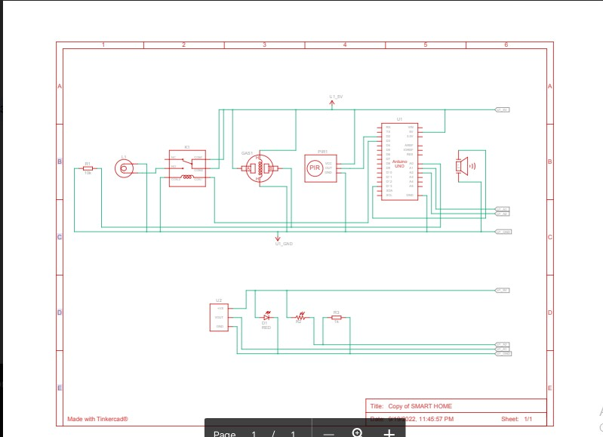

SIMULATION LINK:

https://www.tinkercad.com/things/af2f5Pnx0Jl-copy-of-smarthome/editel

OUTPUT :

